Encouraging more nature-based solutions in urban planning processes through roadmaps and Urban Greening Plans
A roadmap in the context of urban planning can outline and capture a city’s path towards a specific goal. In the context of CLEVER Cities, the roadmaps were used to outline steps towards co-creating local nature-based solution (NbS) plans. These can help cities to create and follow up on their intentions, such as how to overcome barriers and challenges and mainstream NbS replication activities into existing local (and/or national) policy, legislative, governance and citizen engagement structures as well as repeat replication activities in other districts.
The first brief provides insights into the development of a nature-based solution roadmap to support the integration of NbS into existing policy, governance and citizen engagement structures at city level, elucidated through the example of Malmö. The brief also shares experiences with replicating and upscaling the NbS roadmaps and how this work informed the European Commission’s Guidance for the Urban Greening Plans. Relevant steps for developing such a roadmap are outlined in the illustration and summarized in this video.

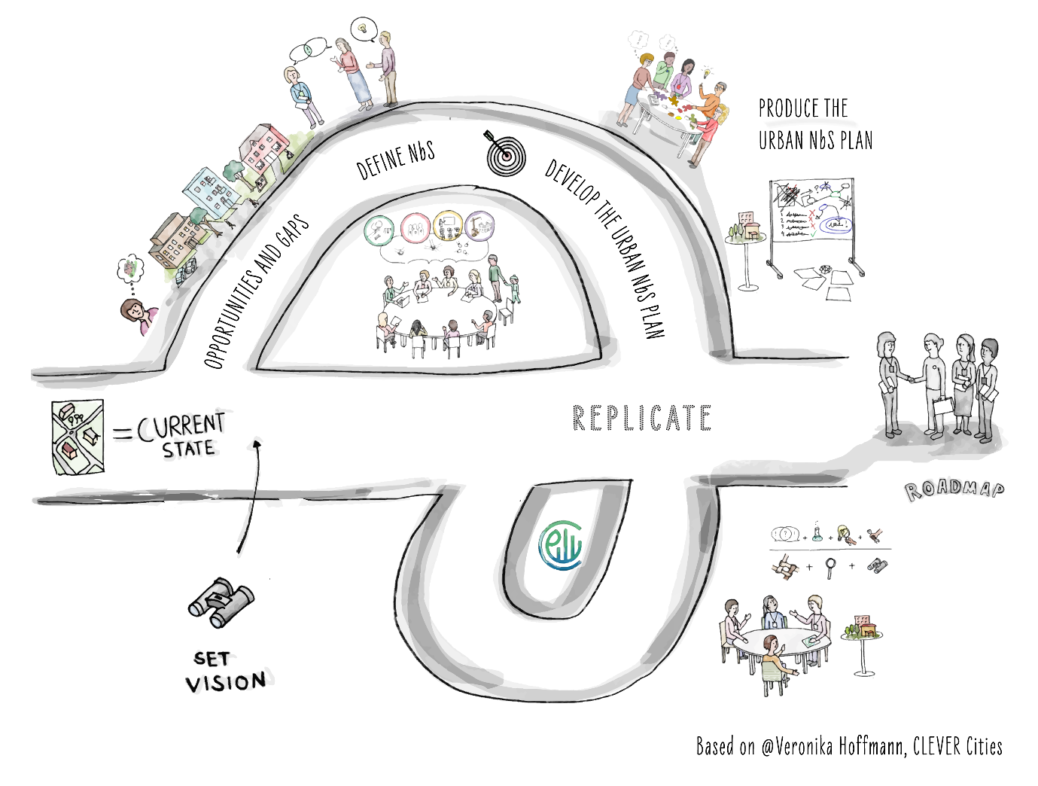
The second brief introduces the concept of Urban Greening Plans (UGPs), which offer governments an actionable strategy for addressing the impacts of biodiversity loss by utilizing NbS as a key approach in urban planning. The related integrated planning approach for urban greening is an innovative planning framework for urban greening that puts co-creation, mainstreaming NbS as well as vertical and horizontal integration at the centre. Uptake of UGPs can be facilitated via a policy context emphasizing co-creation. The brief illustrates this point through the experiences of CLEVER Cities’ partners Madrid and Belgrade. The brief was prepared before the UGP guidance and is based upon evidence indicating the potential of such planning documents. More on the UGPs and how the CLEVER Cities NbS roadmaps supported the process is outlined in this video.

Experiences from #city name# in developing a NbS roadmap: #link to webinar clip#
#links to full policy briefs#

